PROJECT REPORT
Auto Ticket Classification using Flow Designer
Team ID: 6ab6179bdcoae83adb386708
Team: 6
Date: 15 February 2025

ServiceNow • Flow Designer • Incident Management

CONTENTS
1. INTRODUCTION
1.1 Project Overview
1.2 Purpose
2. IDEATION PHASE
2.1 Problem Statement
2.2 Empathy Map Canvas
2.3 Brainstorming
3. REQUIREMENT ANALYSIS
3.1 Customer Journey map
3.2 Solution Requirement
3.3 Data Flow Diagram
3.4 Technology Stack
4. PROJECT DESIGN
4.1 Problem Solution Fit
4.2 Proposed Solution
4.3 Solution Architecture
5. PROJECT PLANNING & SCHEDULING
5.1 Project Planning
6. FUNCTIONAL AND PERFORMANCE TESTING
6.1 Performance Testing
7. RESULTS
7.1 Output Screenshots
8. ADVANTAGES & DISADVANTAGES
9. CONCLUSION
10. FUTURE SCOPE
11. APPENDIX
Source Code (if any)
Dataset Link
GitHub & Project Demo Link

1. INTRODUCTION

1.1 Project Overview
Auto Ticket Classification using Flow Designer is a ServiceNow-based IT service management automation project. When a new Incident is created, a Flow Designer workflow reads the incident details such as Short Description and Description, applies predefined keyword and condition rules, and updates the ticket with an appropriate category, priority, and support group. Notifications can also be triggered for the responsible team.

1.2 Purpose
The purpose of the project is to reduce manual ticket triage, improve consistency in classification and routing, and help support teams respond to incidents more efficiently. The current implementation is rule-based; AI/ML classification is identified as a future enhancement.

2. IDEATION PHASE

2.1 Problem Statement
- Manual categorization of incoming incidents can delay routing to the correct support team.
- Inconsistent category and priority selection can affect ticket handling and response time.
- Support agents may spend time on repetitive triage activities instead of resolution.

2.2 Empathy Map Canvas
The empathy analysis focuses on employees/end users who raise IT incidents and support agents who receive and resolve them. Users expect simple incident creation, correct routing, timely updates, and reduced waiting. Support agents need clearly categorized, prioritized, and assigned tickets.

2.3 Brainstorming
- Automatic incident classification based on keywords and conditions.
- Automatic priority setting based on incident content.
- Automatic support-group assignment and notification.
- Monitoring of workflow execution and classification rules.
- Future extension using AI/ML for more adaptive classification.

3. REQUIREMENT ANALYSIS

3.1 Customer Journey map
The journey follows the ticket lifecycle: ENTICE → ENTER → ENGAGE → EXIT → EXTEND. The requester creates an incident, the system processes and routes it, the support team works on it, the ticket is resolved, and feedback/monitoring can support future improvement.

3.2 Solution Requirement
Functional requirements:
- FR-1: Incident Creation.
- FR-2: Automatic Ticket Classification.
- FR-3: Priority and Assignment.
- FR-4: Notification and Status Update.
Non-functional requirements:
- NFR-1 Usability; NFR-2 Security; NFR-3 Reliability; NFR-4 Performance.
- NFR-5 Availability; NFR-6 Scalability.

3.3 Data Flow Diagram
The data flow connects the Employee/Requester, ServiceNow Incident record, Flow Designer classification and priority rules, support assignment/notification, and the Support Team. The Administrator maintains rules and monitors the workflow.
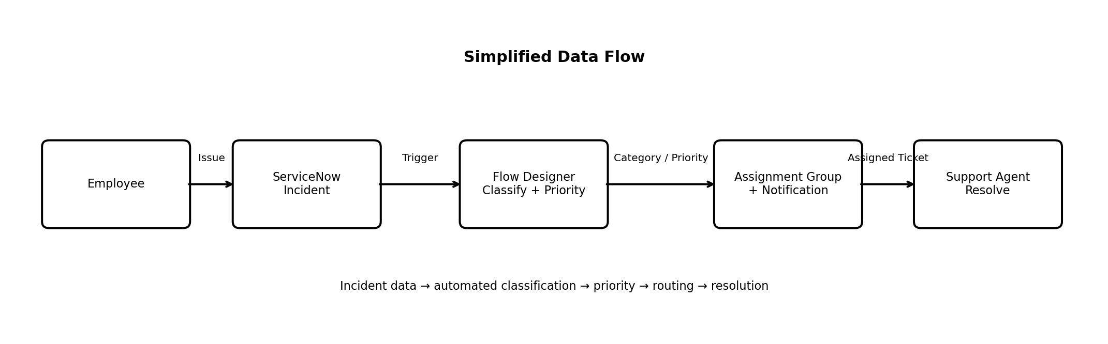
Figure 1. Data Flow Diagram for Auto Ticket Classification

3.4 Technology Stack
Layer | Technology / Component
Platform | ServiceNow Cloud
Workflow | Flow Designer
Data | ServiceNow Incident Table
Security | ServiceNow ACLs and HTTPS
Notifications | ServiceNow notification capability
Future Enhancement | AI/ML-based classification

4. PROJECT DESIGN

4.1 Problem Solution Fit
Customer segments include employees/end users raising IT incidents and service-desk/support teams. Key constraints are manual triage effort, inconsistent classification, delayed routing, and high ticket volume. The proposed solution directly addresses these problems through automated classification, priority setting, routing, and notification within ServiceNow.

4.2 Proposed Solution
- Trigger Flow Designer when an Incident is created.
- Read Short Description and Description.
- Apply predefined keyword/condition rules.
- Set category and priority according to the matching rule.
- Assign the incident to the appropriate support group.
- Send/update notifications where required.
- Maintain rules so administrators can refine classifications.

4.3 Solution Architecture
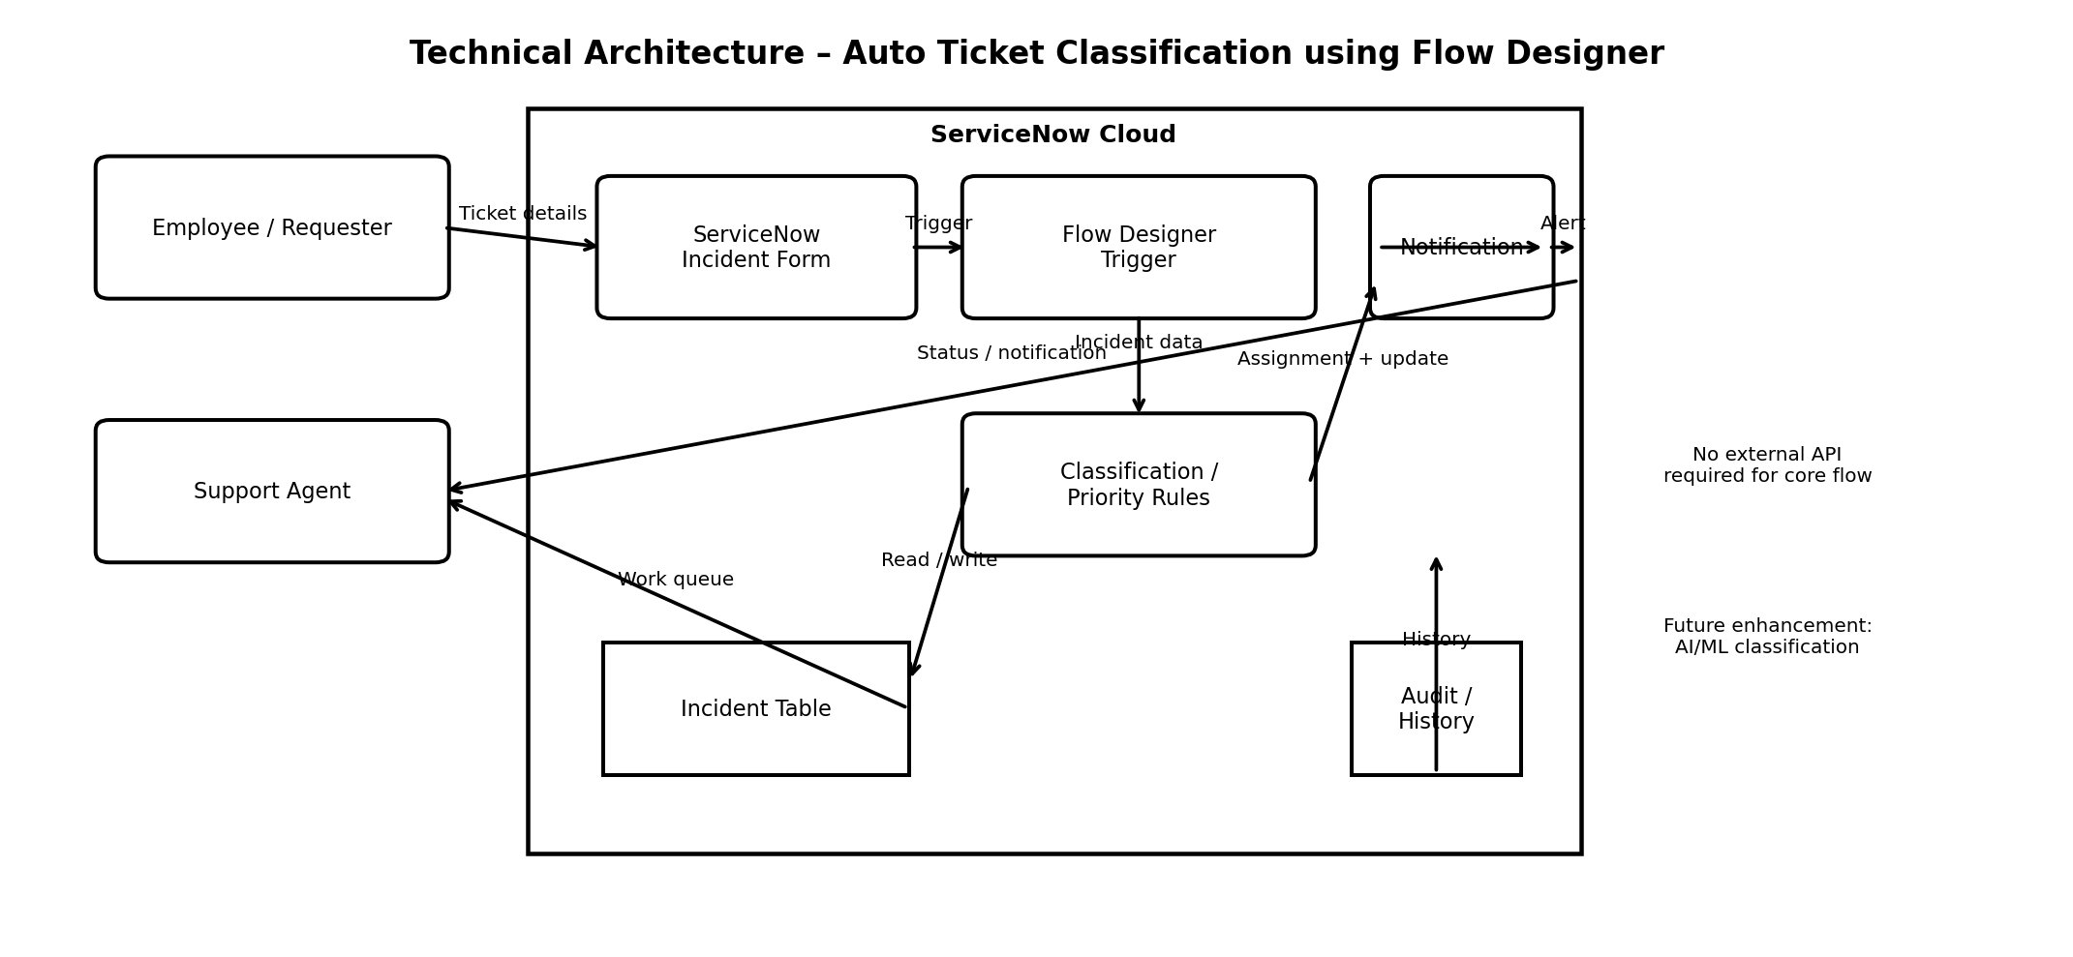
Figure 2. Solution Architecture
The architecture bridges the requester-facing Incident form with Flow Designer automation. The workflow processes the incident, applies classification and priority rules, routes it to the support group, and updates/notifies the relevant users.

5. PROJECT PLANNING & SCHEDULING

5.1 Project Planning
The planning uses two sprints with the story-point scale 1, 2, 3, and 5.
Sprint | Major Work | Story Points | Duration | Velocity
Sprint 1 | Incident creation, classification, priority, assignment & routing | 12 | Sprint 1 | 16 avg.
Sprint 2 | Status, notifications, agent workflow, resolution, administration & future enhancement | 20 | Sprint 2 | 16 avg.
Total |  | 32 | 2 sprints | 16 points/sprint

6. FUNCTIONAL AND PERFORMANCE TESTING

6.1 Performance Testing
Testing focuses on the implemented ServiceNow workflow rather than an ML model. Functional scenarios cover incident input, classification, priority assignment, support-group routing, notification/status handling, and unmatched tickets. Performance scenarios consider flow execution time and processing of multiple incidents.
Test Area | Scenario | Expected Result | Status
Functional | Incident creation | Incident is created with required details | To be verified
Functional | Automatic classification | Matching rule sets the intended category | To be verified
Functional | Priority assignment | Priority is set according to rule | To be verified
Functional | Assignment & notification | Correct group receives routed ticket/notification | To be verified
Performance | Flow execution | Workflow completes within acceptable project environment time | To be verified
Performance | Multiple incidents | Multiple incident records can be processed | To be verified

7. RESULTS

7.1 Output Screenshots
The supplied Final Report template does not contain actual ServiceNow output screenshots. Therefore, this section identifies the screenshots that should be inserted from the implemented project without fabricating evidence.
- Screenshot A – ServiceNow Incident form showing a newly created ticket.
- Screenshot B – Incident after Flow Designer classification with category and priority.
- Screenshot C – Assigned support group / routed incident.
- Screenshot D – Flow Designer execution or notification result.

8. ADVANTAGES & DISADVANTAGES
Advantages
- Reduces repetitive manual triage work.
- Provides consistent rule-based classification.
- Supports automatic priority and routing.
- Can improve visibility and response coordination.
- Can be extended with additional rules and future AI/ML capabilities.
Disadvantages / Limitations
- Current classification depends on predefined keywords and conditions.
- New or ambiguous ticket descriptions may require rule updates.
- The current project does not implement ML training or hyperparameter tuning.
- Actual performance depends on the ServiceNow environment and workflow configuration.

9. CONCLUSION
Auto Ticket Classification using Flow Designer demonstrates how ServiceNow workflow automation can support incident triage by combining ticket classification, priority management, routing, and notification in a single process. The design addresses the identified manual-triage problems while keeping the implementation within the ServiceNow platform.

10. FUTURE SCOPE
- Introduce AI/ML or NLP-based ticket classification.
- Learn from historical incident data to improve classification accuracy.
- Add confidence scoring and human review for uncertain classifications.
- Expand rules and categories as new incident patterns are observed.
- Add richer dashboards and analytics for ticket trends and workflow performance.

11. APPENDIX
Source Code (if any)
No source-code repository or downloadable source package was provided in the supplied Final Report template.
Dataset Link
No external dataset link was provided. The core implementation is based on ServiceNow Incident records and workflow rules.
GitHub & Project Demo Link
No GitHub repository or project demo URL was provided in the supplied materials; insert the official project link here if available.

